Num 23:22
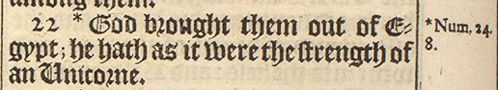

Num 24:8
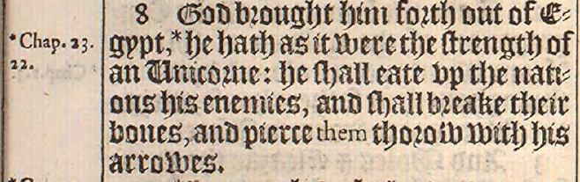

Deu 33:17
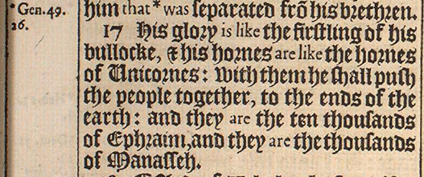

Job 39:9,10
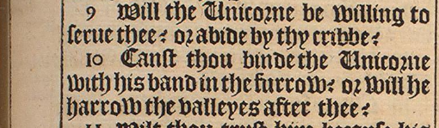

Psalm 22:21
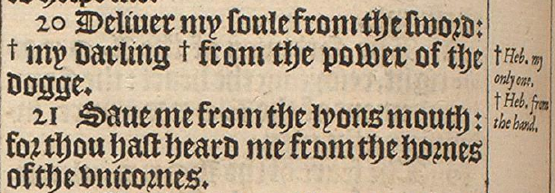

Psalm 29:6
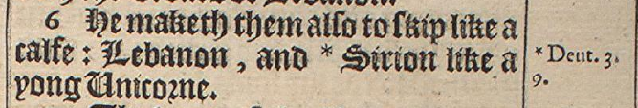

Psalm 92:10
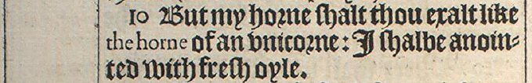

Isaiah 34:7
